Autonomous Self-Healing Infrastructure for Containerized Applications via Ensemble Confidence Scoring

A Synopsis Report

Submitted by
Vaishnav Aron 230120101171
Siddharth Dora 230120101150
Vikash Kumar 230120101174
Tilak Kumar Shah 230120101167

Under the Supervision of

Ms. Akanksha Srivastav
Designation : Assistant Professor

Department of Computer Science and Engineering

In Partial Fulfillment of the Requirements for the Degree of
Bachelor of Technology



DEPARTMENT OF COMPUTER SCIENCE ENGINEERING

TULA’S INSTITUTE, DEHRADUN
(Affiliated to VMSB Uttarakhand Technical University, Dehradun)
December, 2025

TABLE OF CONTENTS

S. No. | CONTENTS | PAGE NO.
1 | INTRODUCTION | 1
2 | BACKGROUND OF THE STUDY | 2
3 | PROBLEM STATEMENT AND GAP ANALYSIS | 4
4 | OBJECTIVES | 5
5 | HARDWARE AND SOFTWARE REQUIREMENTS | 6
6 | TECHNOLOGIES USED | 7
7 | PROPOSED METHODOLOGY | 9
8 | DATASET USED | 11
9 | EXPECTED OUTCOMES | 12
10 | REFERENCES | 14

ABSTRACT

This project presents a Kubernetes-based Progressive Delivery and Automated Rollback system designed to provide a controlled and reliable approach for deploying new versions of containerized applications. Conventional deployment approaches may expose users to a newly released version immediately, increasing the impact of application errors, performance degradation, or configuration issues. The proposed system addresses this challenge by using Argo Rollouts to implement a controlled canary deployment in which a new application version is introduced gradually while the existing stable version continues to serve traffic. During the rollout, application health and performance metrics are collected using Prometheus and visualized through Grafana, providing continuous observability of the deployment process. Argo Rollouts uses configured analysis conditions to evaluate the canary version and determine whether the rollout should continue, be promoted, or automatically aborted. If the new version satisfies the defined conditions, traffic is progressively shifted toward the canary version until it becomes the stable release. If the canary fails the configured analysis, the rollout is automatically stopped and traffic is restored to the previously stable version, reducing the need for manual intervention. The system is implemented using Kubernetes-native deployment resources and open-source cloud-native technologies, providing a practical demonstration of progressive delivery, continuous monitoring, and automated rollback. The project aims to demonstrate how controlled application releases can reduce deployment risk, improve release visibility, and provide a safer mechanism for introducing application updates in containerized environments.

Keywords: Progressive Delivery, Kubernetes, Argo Rollouts, Canary Deployment, Automated Rollback, Prometheus, Grafana, Containerized Applications, Cloud-Native Deployment.

- INTRODUCTION

Modern software applications are increasingly developed and deployed using containerized and cloud-native technologies such as Kubernetes. Kubernetes provides automated management of application workloads, enabling applications to be deployed, scaled, and updated in a consistent environment. However, releasing a new application version directly to all users can introduce operational risks. A newly deployed version may contain software defects, configuration errors, compatibility issues, or performance problems that may not be identified before deployment. If the faulty version receives complete application traffic immediately, the resulting failure can affect a large number of users and may require manual intervention to restore the previous stable version.

Traditional deployment approaches generally focus on replacing an existing application version with a newer version, while the health of the new release is often verified separately by developers or operations teams. Although Kubernetes provides mechanisms for controlled updates and rollback, modern application delivery increasingly requires more controlled release strategies in which a new version can be exposed gradually and evaluated before being made available to all users. Progressive delivery addresses this requirement by introducing a controlled transition between application versions. One of the commonly used approaches is canary deployment, where a small portion of traffic is initially directed to the new version while the stable version continues serving the majority of the traffic. The new version can then be progressively exposed to more traffic when it demonstrates acceptable behavior.

The combination of progressive delivery with continuous monitoring can further improve the safety of application releases. Argo Rollouts extends Kubernetes deployment capabilities by providing advanced rollout strategies such as canary deployments and automated promotion or rollback. Prometheus can collect application and system metrics during the rollout, while Grafana can provide visualization of these metrics and the current deployment state. By connecting deployment progression with observable application behavior, the release process can be made more controlled and transparent.

The proposed project implements a Progressive Delivery and Automated Rollback system using Kubernetes, Argo Rollouts, Prometheus, and Grafana. The system introduces a new application version through a controlled canary rollout while maintaining the existing stable version. During the rollout, relevant application metrics are monitored and evaluated against predefined conditions. When the canary version satisfies the configured conditions, the rollout is progressively advanced and eventually promoted. When the new version fails the defined analysis conditions, the rollout is automatically aborted and the stable version is retained, reducing dependence on manual intervention.

The proposed system is intended to provide a practical demonstration of safer cloud-native application deployment. It can be used in development, testing, and education1al environments to demonstrate how progressive delivery, observability, and automated rollback can work together within a Kubernetes-based application deployment workflow. By providing controlled release progression and automated recovery from an unsuccessful deployment, the project demonstrates an approach that can reduce the potential impact of faulty application releases and improve visibility into the deployment process.

2. BACKGROUND OF THE STUDY
Modern cloud-native application deployment has increasingly moved toward controlled release strategies that reduce the risk associated with introducing new application versions. Kubernetes provides a standard mechanism for updating applications through its Deployment resource and RollingUpdate strategy. This approach gradually replaces existing application instances with the new version, but it provides limited control over progressive traffic exposure and does not inherently connect rollout decisions with application-level performance metrics [1].

Progressive delivery extends conventional continuous delivery by introducing controlled and gradual application releases. Canary deployment is one of the commonly used approaches, where a new application version is initially exposed to a limited portion of the workload or traffic while the existing stable version continues to operate. The behavior of the new version can then be observed before progressively increasing its exposure. This approach reduces the initial impact of an unsuccessful release and provides an opportunity to evaluate the new version before complete promotion [2].

Argo Rollouts provides Kubernetes-native capabilities for implementing progressive delivery strategies such as canary and blue-green deployments. It extends the standard Kubernetes deployment model with rollout steps, controlled progression, traffic management, and automated promotion or abortion mechanisms. Canary steps can define different levels of exposure to the new version, allowing the rollout to progress incrementally instead of immediately replacing the stable version [2].

An important feature of progressive delivery is the integration of application metrics with deployment decisions. Argo Rollouts provides AnalysisTemplate and AnalysisRun resources that can evaluate metrics obtained from external providers. Prometheus can be configured as a metric provider, allowing application measurements such as request success rate or other monitored indicators to be evaluated during a rollout. Depending on the configured conditions, a rollout can continue when the analysis succeeds or be aborted when the analysis fails [3], [4].

Prometheus is widely used for collecting and querying time-series monitoring data, making it suitable for observing application behavior during deployment. Grafana can then provide dashboards for visualizing these metrics and the state of the application. The combination of monitoring and visualization provides greater visibility into the behavior of different application versions during a progressive rollout [4], [5].

Existing Argo Rollouts demonstrations further show the practical use of canary deployments, progressive rollout steps, metric-based analysis, and unsuccessful rollout handling. These examples demonstrate that the required technologies for controlled deployment and automated rollback are already available as established cloud-native components [6].

From the reviewed approaches, it can be observed that Kubernetes provides the basic deployment foundation, while Argo Rollouts adds progressive delivery and rollout analysis capabilities, and Prometheus and Grafana provide monitoring and visualization. However, these capabilities must be appropriately configured and integrated to form a complete workflow in which deployment progression is connected with application health and an unsuccessful release can be automatically stopped. Therefore, the proposed project focuses on implementing and demonstrating this integrated workflow using Kubernetes, Argo Rollouts, Prometheus, and Grafana rather than proposing a new deployment algorithm.
3. PROBLEM STATEMENT and GAP ANALYSIS
Modern cloud-native applications require reliable methods for introducing new software versions without unnecessarily exposing users to deployment failures. Kubernetes provides mechanisms for updating applications through rolling deployments, while progressive delivery tools such as Argo Rollouts provide controlled canary releases and rollout management. Monitoring platforms such as Prometheus and Grafana further provide the ability to observe application behavior during deployment. However, these capabilities need to be appropriately configured and integrated to create a complete workflow in which a new version is gradually introduced, continuously evaluated, and automatically stopped when it does not satisfy predefined conditions.

Problem Statement:
A conventional application deployment can expose a newly released version to a large number of users before sufficient runtime validation has been performed. If the new version introduces increased errors, degraded response performance, or other application-level issues, detecting and recovering from the faulty release may require manual intervention. This can increase the potential impact of an unsuccessful deployment and make the release process less controlled.
The project therefore addresses the problem of safely deploying new versions of containerized applications by progressively introducing the release, monitoring its behavior, and automatically rolling back an unsuccessful deployment.

Gap Analysis:
The existing Kubernetes ecosystem provides the individual technologies required to address this problem. Kubernetes provides container orchestration and application deployment, Argo Rollouts provides progressive canary rollout capabilities, Prometheus provides application and system metric collection, and Grafana provides visualization of monitored data. However, the practical requirement is to integrate these capabilities into a single, demonstrable deployment workflow in which application health is connected with rollout progression.

The proposed project addresses this implementation requirement through the following workflow:
Canary Release → Progressive Traffic/Application Exposure → Metric Monitoring → Analysis → Promotion or Automated Rollback
During a successful deployment, the new version is progressively advanced after satisfying the configured conditions. During an unsuccessful deployment, the rollout is aborted and the stable version is retained. This provides a controlled mechanism for validating a release before it becomes the primary application version.
The project is therefore positioned as a software implementation and integration project, rather than claiming a new research algorithm or novel scientific discovery. Its primary contribution is the practical demonstration of progressive delivery, metric-based deployment analysis, observability, and automated rollback using established Kubernetes-native technologies.

4. OBJECTIVES

The primary objective of the proposed project is to design and implement a Kubernetes-based progressive delivery system that enables controlled application releases, continuous health monitoring, and automated recovery from unsuccessful deployments. The specific objectives are:
- To implement progressive canary deployment for a containerized application using Kubernetes and Argo Rollouts, allowing a new application version to be introduced gradually while minimizing its initial exposure.
- To configure controlled rollout progression so that the canary version is progressively exposed while the stable version remains available, enabling the new release to be evaluated before complete promotion.
- To integrate Prometheus-based monitoring and analysis for collecting and evaluating relevant application health and performance metrics throughout the rollout process.
- To configure automated rollout decisions using predefined analysis conditions, allowing the deployment to continue when the canary demonstrates acceptable behavior and to stop when the defined conditions are not satisfied.
- To implement automated rollback that restores the previously stable application version when the canary release fails the configured analysis conditions, thereby reducing the need for manual intervention.
- To provide real-time visualization using Grafana for monitoring application metrics, rollout status, canary progression, and overall deployment behavior.
- To validate the complete progressive delivery workflow through controlled successful and failed deployment scenarios, demonstrating canary progression, metric-based analysis, promotion, and automated rollback.
- To demonstrate an integrated cloud-native deployment approach in which application delivery, monitoring, analysis, and rollback are connected within a single Kubernetes-based workflow, providing a practical foundation for safer and more observable application releases.

5. HARDWARE AND SOFTWARE REQUIREMENTS

The successful development, deployment, and testing of the proposed progressive delivery system require a suitable computing environment capable of running containerized workloads and Kubernetes components. The required resources are divided into hardware and software requirements.

5.1 Hardware Requirements
Component | Minimum Requirement
Processor | Intel Core i5 / AMD Ryzen 5 or equivalent, 4+ cores
RAM | 8 GB minimum; 16 GB recommended
Storage | 20 GB or more free space; SSD recommended
Network | Internet connection for downloading container images, tools, and dependencies
Display | Standard monitor with sufficient resolution for development and Grafana dashboards

5.2 Software Requirements
Category | Software / Requirement
Operating System | Windows 10/11, Linux, or macOS
Container Runtime | Docker / Docker Desktop
Container Orchestration | Kubernetes
Progressive Delivery | Argo Rollouts
Monitoring | Prometheus
Visualization | Grafana
Programming / Configuration | YAML and supporting application code as required
Development Environment | Visual Studio Code or equivalent IDE
Version Control | Git and GitHub
Web Browser | Google Chrome, Microsoft Edge, or Mozilla Firefox

6. TECHNOLOGIES USED
The proposed system uses containerization, Kubernetes-based orchestration, progressive delivery, monitoring, and development technologies to implement controlled application deployment and automated rollback.

6.1 Application and Backend Technologies
- Node.js – Used as the runtime environment for the backend application being deployed and tested through the progressive delivery workflow.
- Express.js – Used to develop the backend API and provide application endpoints whose behavior can be monitored during deployment.

6.2 Containerization and Orchestration Technologies
- Docker – Used to package the application and its dependencies into container images.
- Kubernetes – Used to deploy, manage, and orchestrate the containerized application.

6.3 Progressive Delivery and Deployment Technologies
- Argo Rollouts – Used to implement canary-based progressive delivery, control rollout progression, evaluate deployment conditions, and perform automated rollback when the configured conditions are not satisfied.

6.4 Monitoring and Observability Technologies
- Prometheus – Used to collect and evaluate application and deployment-related metrics during the rollout.
- Grafana – Used to visualize monitoring metrics and provide dashboards for observing application and deployment behavior.

6.5 Configuration Technologies
- YAML – Used for defining Kubernetes resources, Argo Rollouts configurations, deployment strategies, services, and analysis configurations.

6.6 Development and Version Control Tools
- Visual Studio Code – Used as the development and configuration environment.
- Git – Used for source-code and configuration version control.
- GitHub – Used for maintaining and managing the project source code and configuration files.

7. PROPOSED METHODOLOGY
The proposed methodology implements a controlled deployment workflow in which a new version of a containerized application is gradually introduced, monitored, evaluated, and either promoted or automatically rolled back based on predefined conditions.

7.1 Application Containerization
The application is developed using Node.js and Express.js and packaged into a Docker container image along with its required dependencies. The container image provides a consistent environment for deploying the application on Kubernetes.

7.2 Kubernetes Deployment
The Dockerized application is deployed on a Kubernetes cluster. Kubernetes manages the application pods and provides the deployment environment required for running the stable and newly released application versions.

7.3 Canary-Based Progressive Delivery
Argo Rollouts is configured to manage the progressive deployment of the new application version. Instead of replacing the existing version immediately, the new version is introduced as a canary release. The rollout proceeds through predefined stages while the stable version remains available.

7.4 Monitoring and Analysis
During the rollout, Prometheus collects the configured application and deployment metrics. Argo Rollouts uses the defined analysis conditions to evaluate the behavior of the canary version during the deployment process.

7.5 Rollout Decision
Based on the configured analysis conditions, the rollout follows one of two paths:
- Successful analysis: The canary continues through the defined rollout stages and is eventually promoted as the stable version.
- Failed analysis: The rollout is aborted and the previously stable version is restored automatically.

7.6 Visualization and Validation
Grafana is used to visualize the collected metrics and observe application and deployment behavior. The complete workflow is validated using successful and failed deployment scenarios to demonstrate progressive rollout, analysis, promotion, and automated rollback.

8. DATASET USED
The project uses synthetically generated runtime workload data for testing and validation of the progressive delivery system. Test requests are generated under different application conditions, including normal operation, increased load, and failure scenarios. The resulting application and deployment metrics are collected using Prometheus and evaluated against the predefined thresholds configured for the canary rollout.
The generated workload data is used to validate the behavior of the system during canary progression, successful promotion, and automated rollback. No external or pre-existing dataset is required for the implementation.

- EXPECTED OUTCOMES
The proposed project is expected to provide a functional Kubernetes-based progressive delivery system capable of managing controlled application releases, monitoring deployment behavior, and automatically responding to unsuccessful deployments.
The expected outcomes of the project are:
- Controlled Canary Deployment
The system is expected to introduce a new application version gradually instead of exposing the complete application to the new release at once. This will allow the canary version to be evaluated during the deployment process before its complete promotion.
- Continuous Monitoring
Prometheus is expected to collect relevant application and deployment metrics during the rollout, while Grafana will provide visual dashboards for observing the collected metrics and deployment behavior.
- Automated Rollout Decisions
The system is expected to evaluate the canary version using predefined analysis conditions and thresholds. Based on the observed metrics, the rollout will either continue toward promotion or be stopped when the configured conditions are not satisfied.
- Automated Rollback
When a canary deployment fails the configured analysis conditions, Argo Rollouts is expected to automatically abort the rollout and restore the previously stable application version, reducing the need for manual intervention.
- Deployment Validation
The complete workflow is expected to be validated through controlled deployment scenarios, including successful releases and intentionally introduced failure or degraded-performance conditions.
- Observable Deployment Workflow
The project is expected to provide visibility into the application state, rollout progression, monitoring metrics, and final deployment decision through the combined use of Argo Rollouts, Prometheus, and Grafana.
- Practical Cloud-Native Implementation
The final system is expected to demonstrate how Kubernetes-based deployment, progressive delivery, monitoring, and automated recovery mechanisms can be used together to create a controlled application release workflow.
Overall, the expected outcome is a working demonstration of progressive application delivery with monitoring-based analysis and automated rollback, providing a practical implementation of the proposed methodology.

- REFERENCES

[1] Kubernetes, “Deployments,” Kubernetes Documentation. Kubernetes Documentation
[2] Kubernetes, “Update a Deployment Without Downtime,” Kubernetes Documentation. Kubernetes Rolling Update Documentation
[3] Argo Project, “Argo Rollouts – Concepts,” Argo Rollouts Documentation. Argo Rollouts Concepts
[4] Argo Project, “Canary Deployment Strategy,” Argo Rollouts Documentation. Argo Rollouts Canary Documentation
[5] Argo Project, “Analysis & Progressive Delivery,” Argo Rollouts Documentation. Argo Rollouts Analysis Documentation
[6] Argo Project, “Getting Started,” Argo Rollouts Documentation. Argo Rollouts Getting Started
[7] Prometheus Authors, “Overview,” Prometheus Documentation. Prometheus Documentation
[8] Prometheus Authors, “First Steps with Prometheus,” Prometheus Documentation. Prometheus First Steps
[9] Grafana Labs, “Prometheus Data Source,” Grafana Documentation. Grafana Documentation
[10] Docker Inc., “What is Docker?,” Docker Documentation. Docker Documentation

System Architecture Diagram:
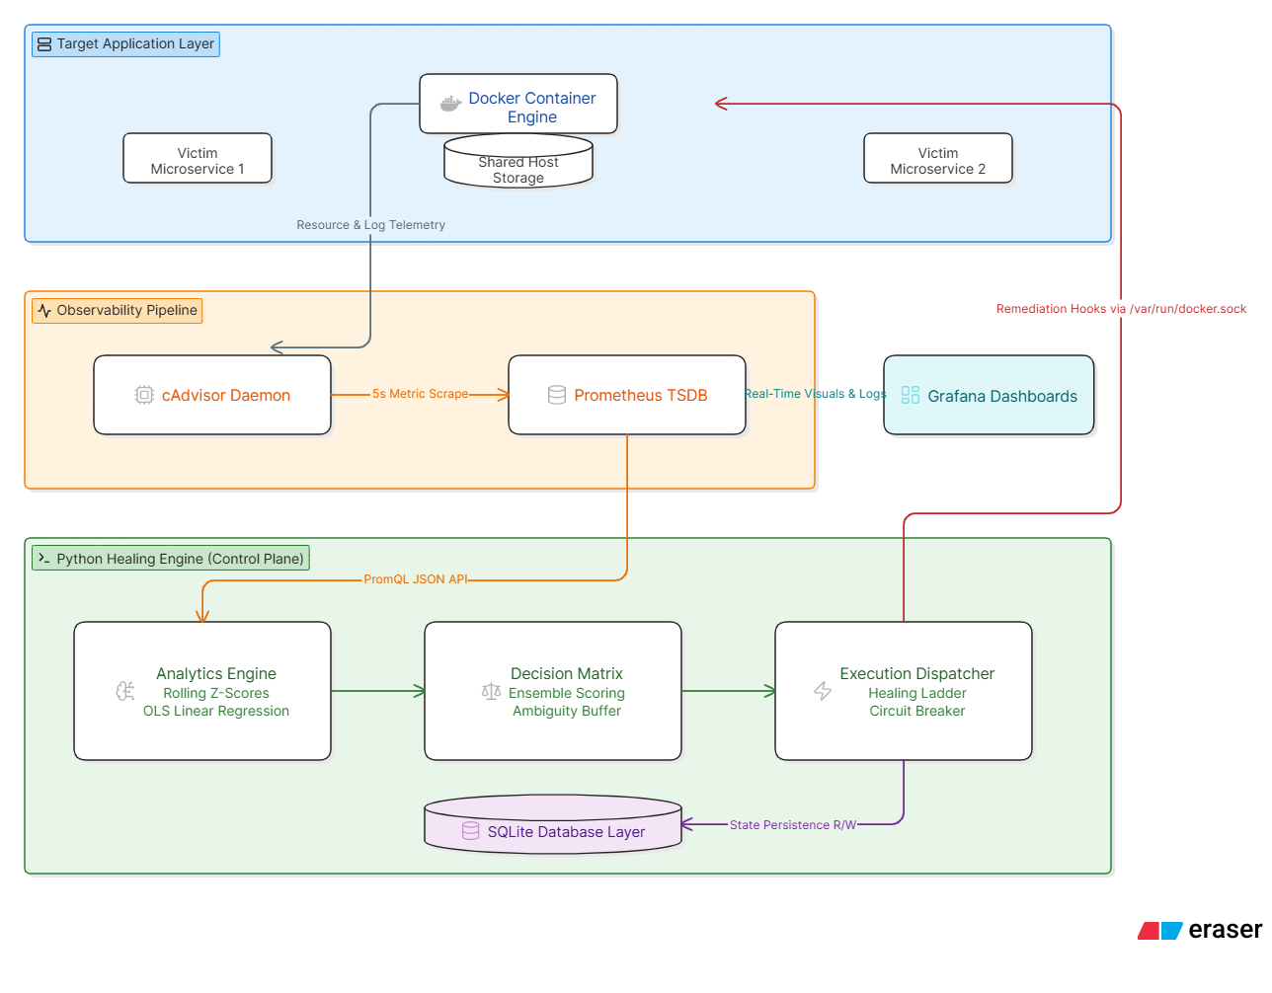

Algorithmic Program Flowchart:
